**WORST CASE COMPLEXITY**

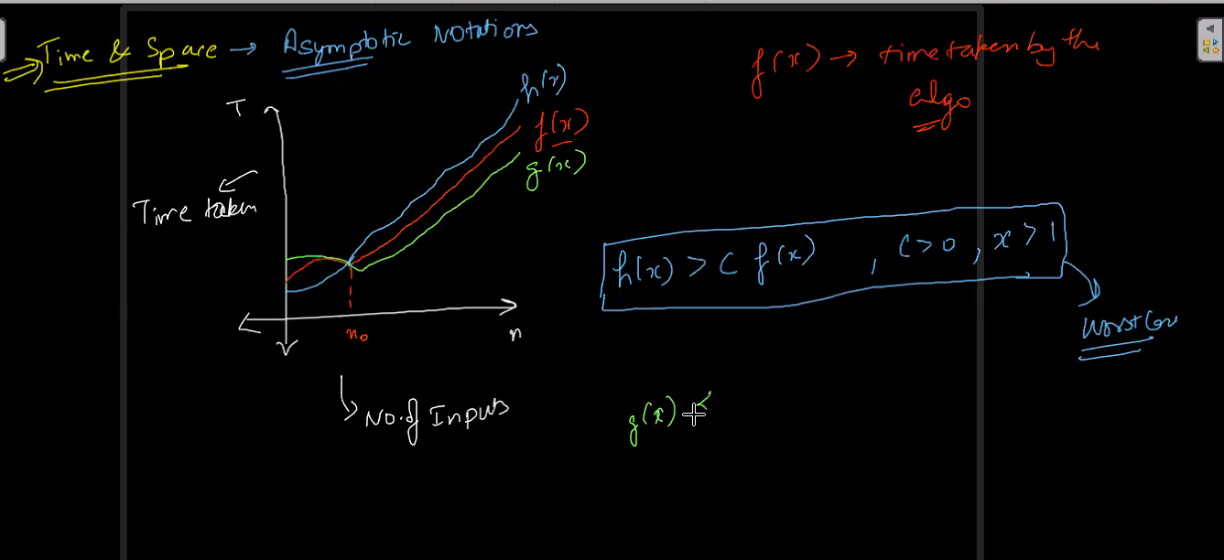

**OMEGA AVERAGE AND WORST**

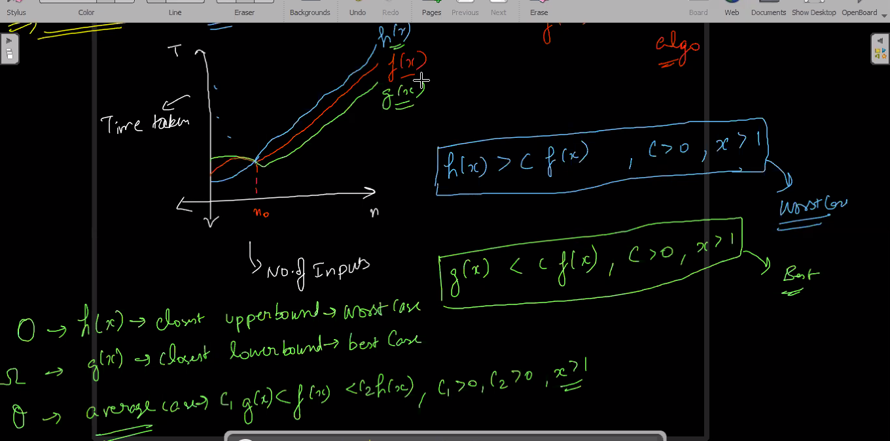

**COMPLEXITY OF LOOPS**

**1-O(n^2 ) or exact complexity is O(15*n*n)**

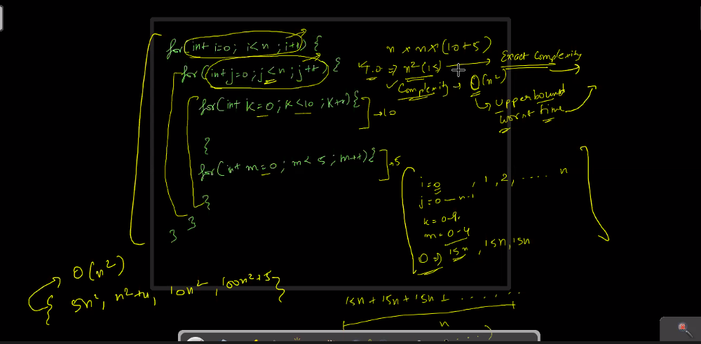

**Linear Search**

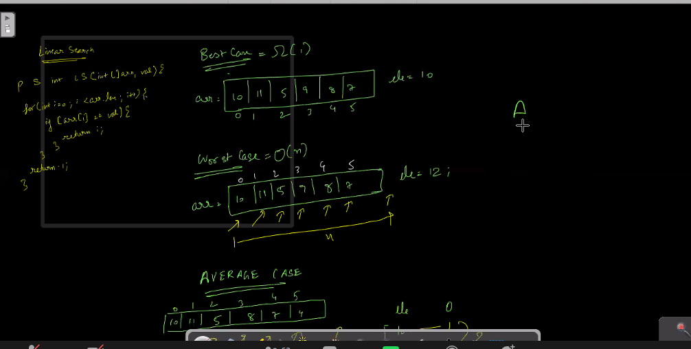

**AVERAGE CASE**

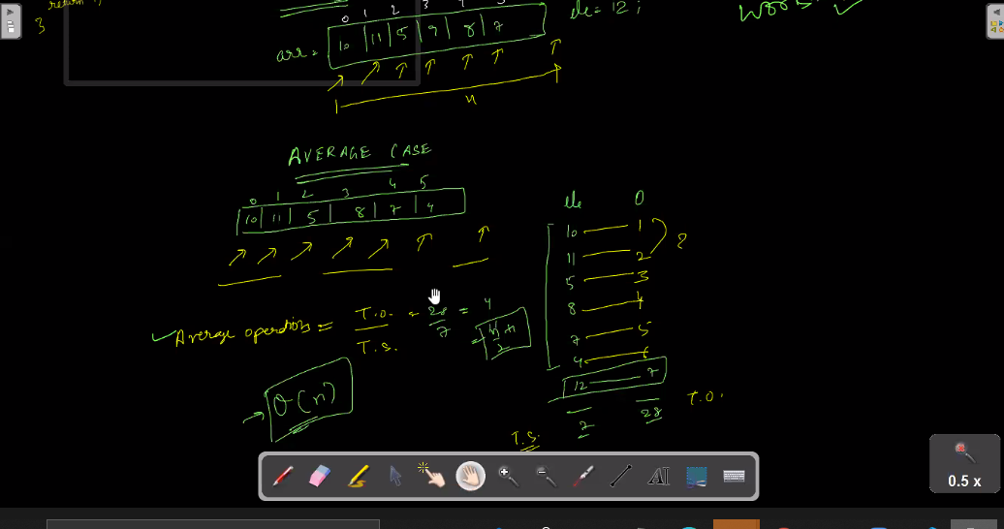

**BINARY SEARCH**

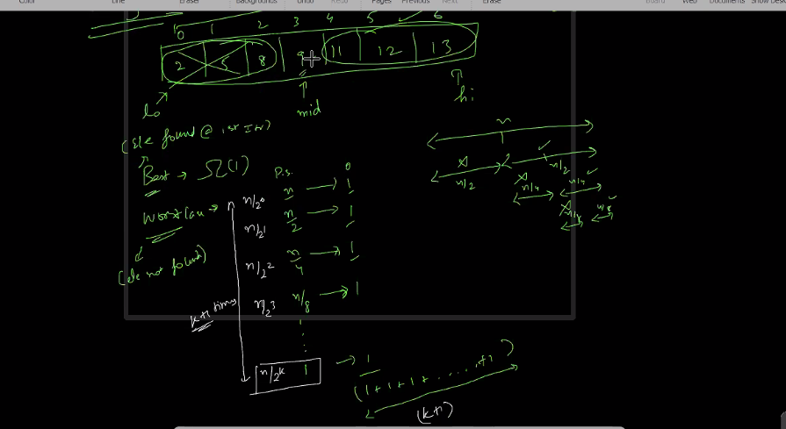

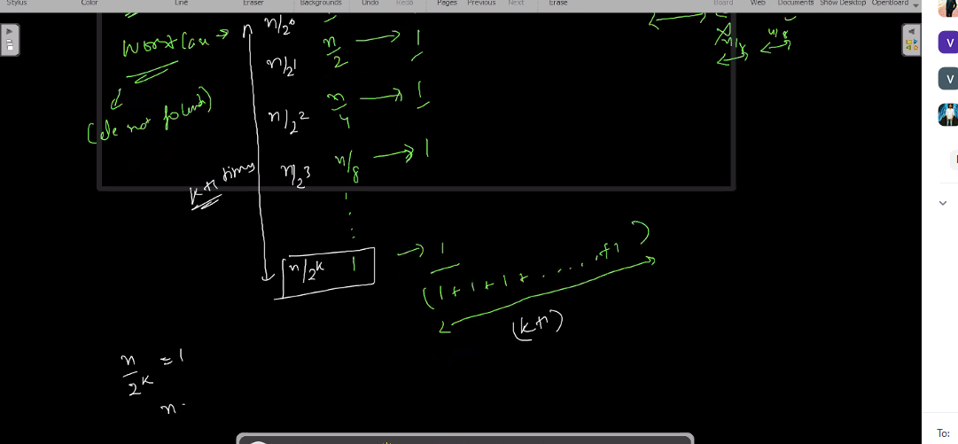

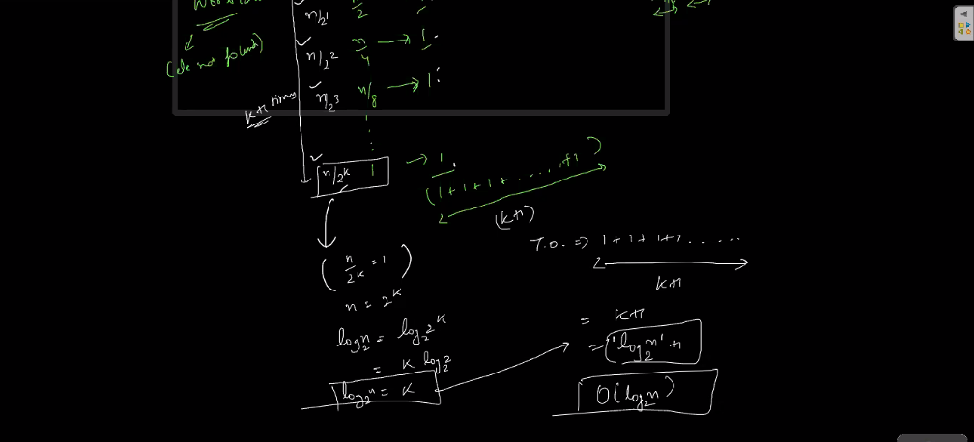

**PRACTICE QUESTIONS COMPLEXITY**

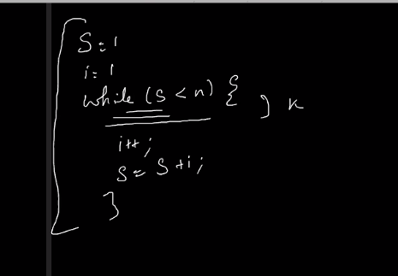

**ANS FOR THIS IS O(sqrt(n))**

**QUESIITIONN- 2**

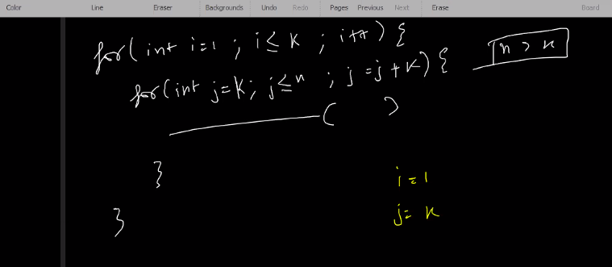

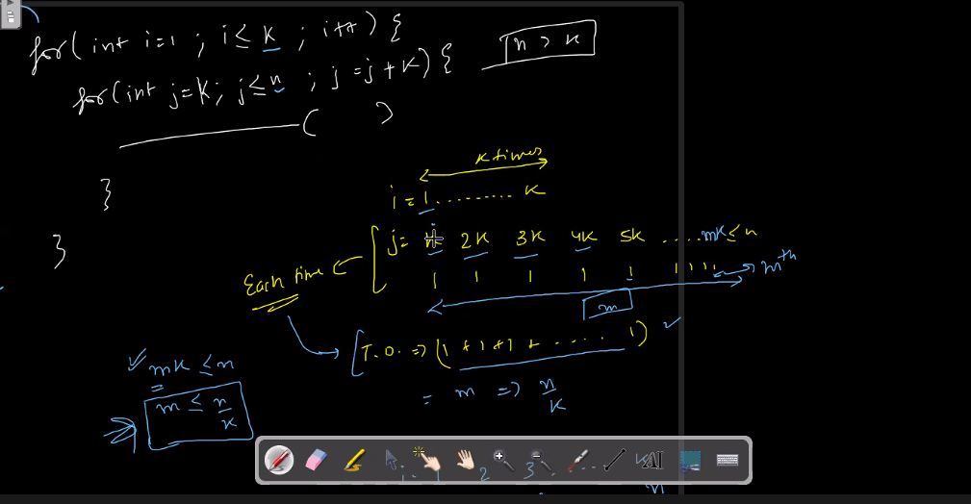

**SOLN IS : - O(N)**

**QUESTION -3 TYPE-3**

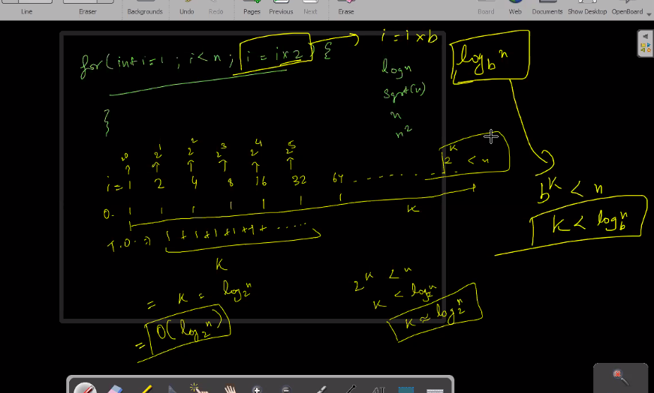

**ANSWER – O ( logn base k to the N)**

**QUESTION TYPE- 4**

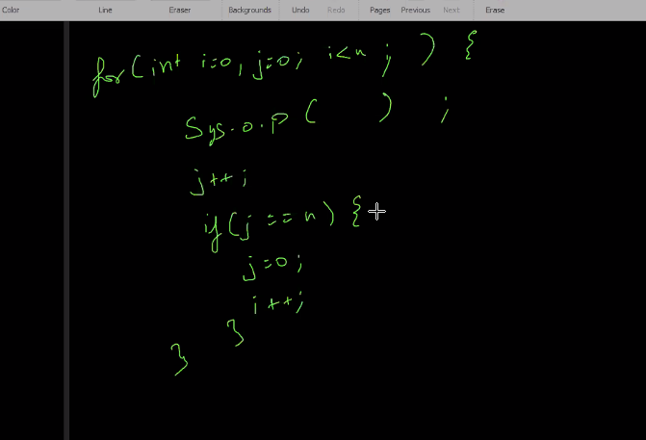

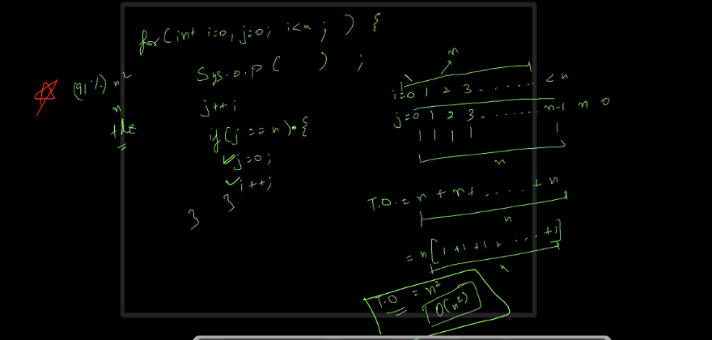

**Solution for this will be : - O(n^2)**

**BUBBLE SORT ANALYSIS**

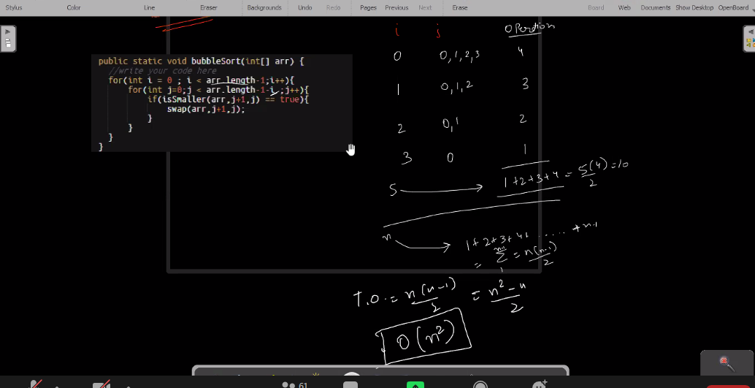

**merger SORT ANALYSIS**

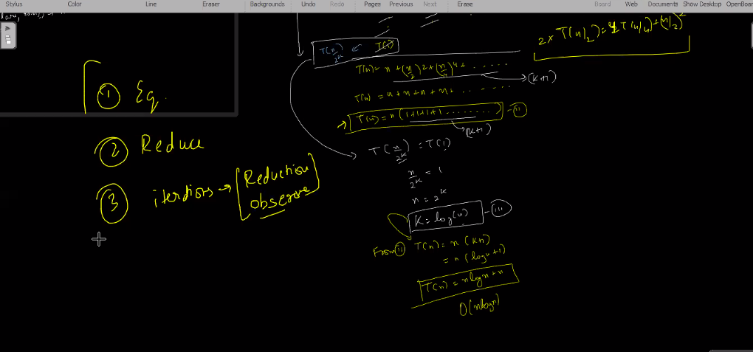

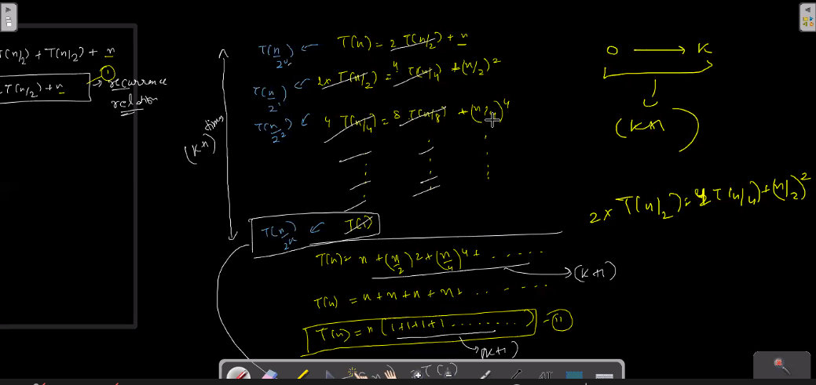

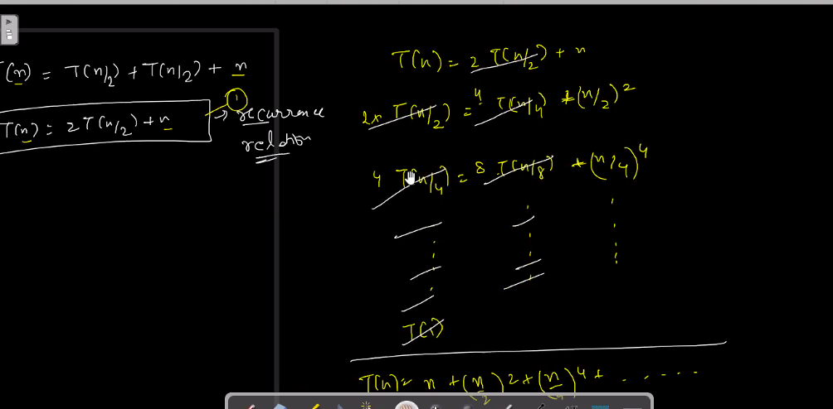

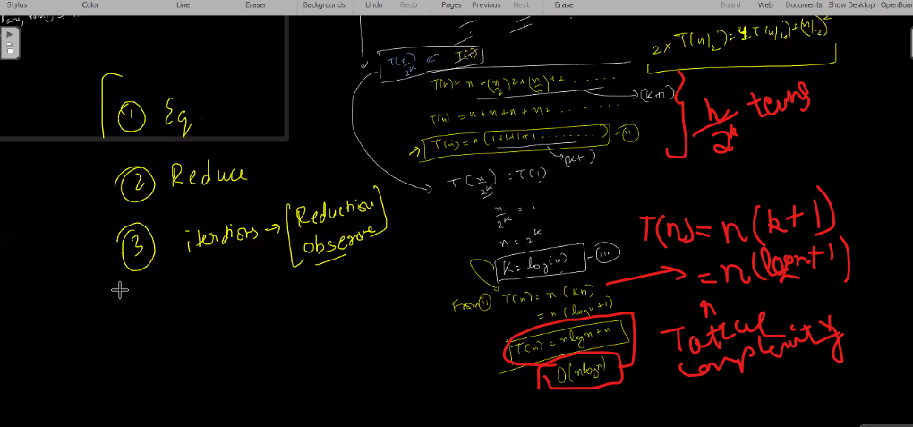

**QUICK SORT ANALYSIS**

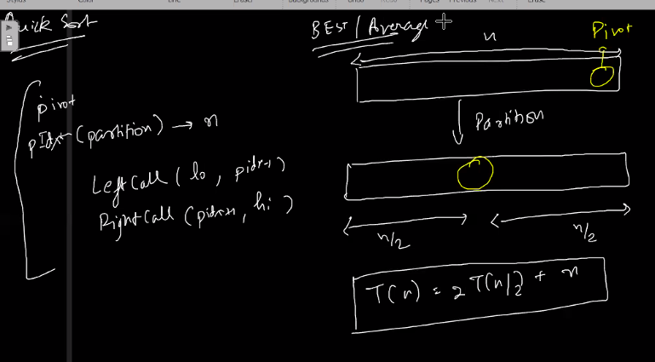

**QUICK SELECT BEST AND WORST**

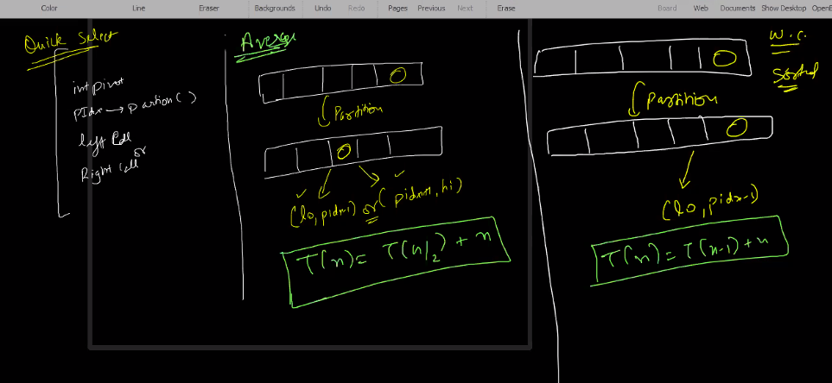

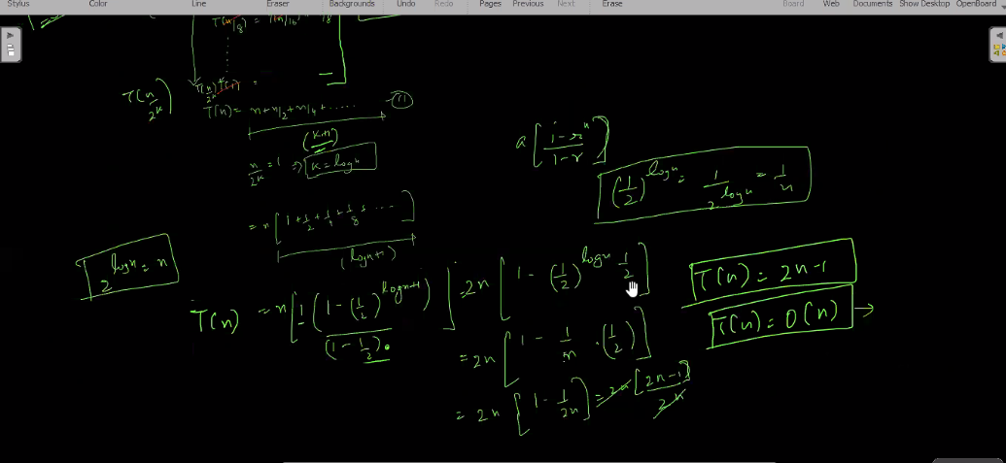

**RECURRENCE RELATION TYPE QUESTIONS**

**Q-1**

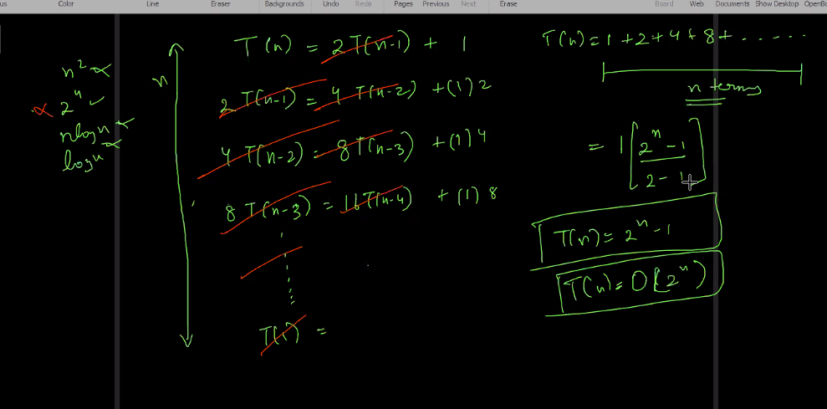

**SOLN- O(2^n)**

**subsequence**

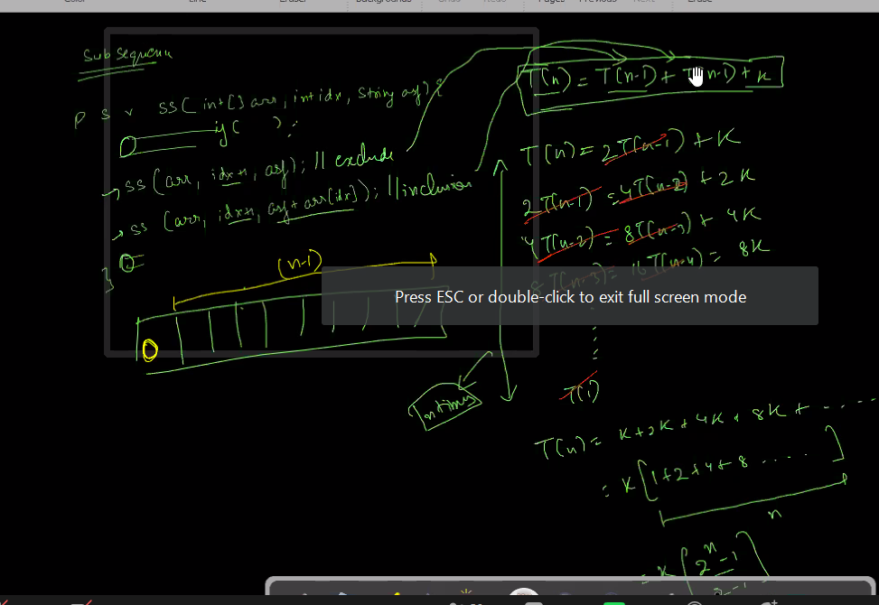

**MAZEPATH**

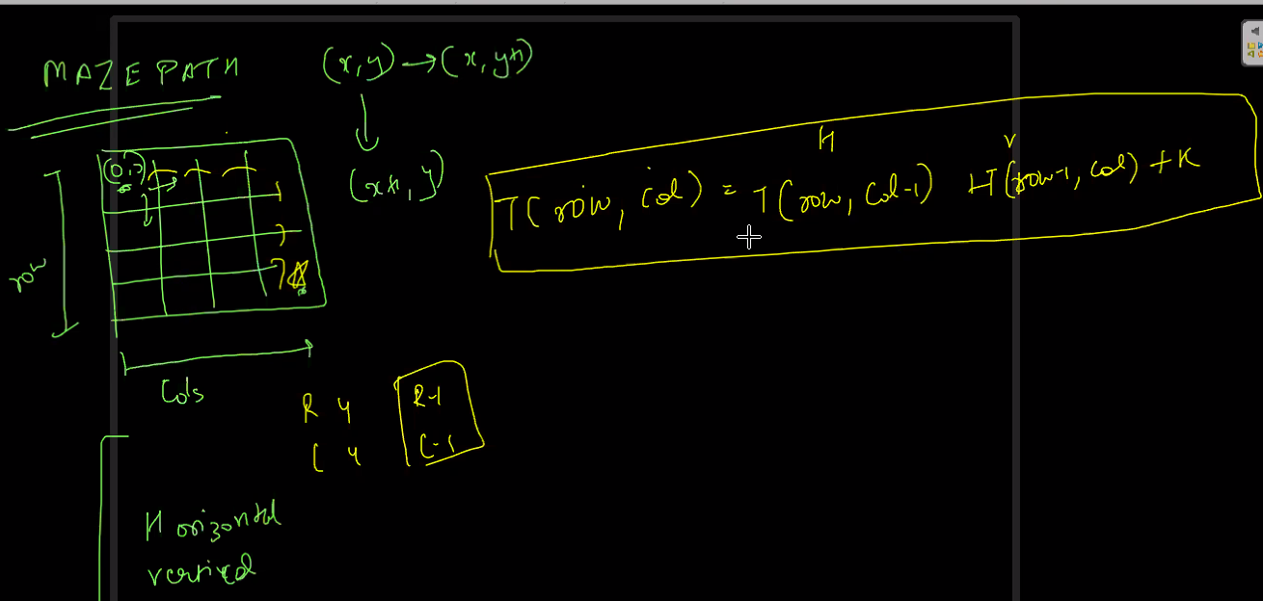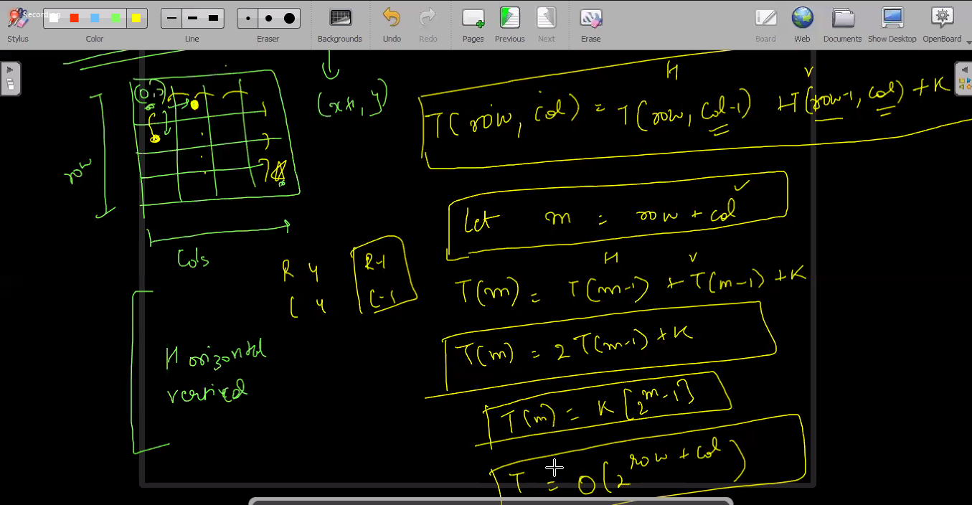

**Soln – O( 2^row+col )**

